**Villacreces *Sunset*,**

**a unique sunset among vineyards**

**Ribera del Duero, July 2024. Finca Villacreces will welcome autumn and the grape harvest on September 14 with its most magical event, as it will have the sunset as a backdrop. The highlight of the event will be a live concert by the group 'Wine Notes'.**

Finca Villacreces vineyards are surrounded by nature and centuries-old pine forests that embrace the Duero River to the north and east of the Finca. An idyllic setting that shines even more at sunset, when the sun falls on the horizon.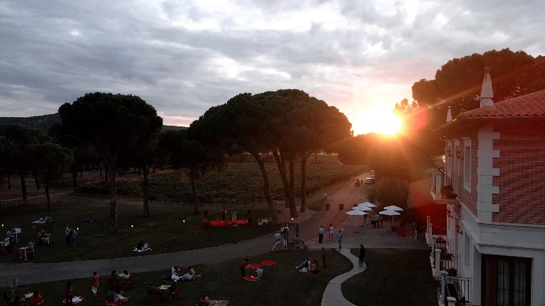

A **great show** that wine lovers will enjoy again on **Saturday, September 14**, starting at 6.30 pm.

Two and a half hours of private event in which attendees can tour the vineyards, watch the preparation of the grape harvest and, at the same time, listen to live music by the band Wine Notes, which will cover pop and rock songs in Spanish and English. All this while waiting for the magic hour: the sunset among the vines.

Finca Villacreces will open the doors of the winery **until 9:00 pm** to share one of the most beautiful sunsets of the Golden Mile of wine.

The ticket, which can already be purchased through the website: www.villacreces.com, is priced at **€30.00 and includes three glasses of wine - Flor de Vetus Verdejo, Pruno and Finca Villacreces** - accompanied by a **tasting of Ibéricos** de la marca Alhándiga de Salamanca and a sweet for dessert.

The grass area surrounding the winery is the place chosen to enjoy the wines, the gastronomy and the opportunity provided by nature to experience this live show. It is recommended to bring a blanket to be able to sit on the lawn and in front of the stage.

***Informative note:***

*Finca Villacreces has been hidden, for centuries, in a unique natural environment, between its vineyards, the Duero and a forest of centenary pines. All this interweaving of nature and vineyards has placed Finca Villacreces among the 10 most visited wineries in Ribera del Duero. It has a 64-hectare vineyard with which it produces the wines Pruno (best wine in the world quality/price in 2012 and 2015) Finca Villacreces, Specimen and Nebro. It also achieved, in 2020, the Travellers Choice Award from Tripadvisor.*

**For more information:**

Finca Villacreces- Iván Pérez – [iperez@artevino.es](mailto:iperez@artevino.es) - 616 510 586

Ticket sale: [www.villacreces.com](http://www.villacreces.com)

10vcomunicación – Victoria Díez - [victoria@10vcomunicacion.es](mailto:victoria@10vcomunicacion.es) - 629 682 802